

 | 
 | 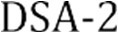
 | 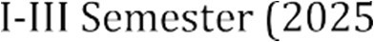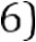
 | MD Razia
 | P. Teja
 | 2520030569
 | CSE
 | CO - 1

Case Study topic: Smart Logix-Logistics& Supply chain optimization system

Work Done Summary:
In this case study, we implemented an AVL Tree for managing Smart l
Logix

Developed an intelligent logistics and supply chain management platform to improve operational efficiency, reduce transportation costs, optimize inventory management, and provide real-time visibility across the supply chain. Implementation Details:
- Created an AVL Tree structure for storing movie titles.
- Inserted movie records into the AVL Tree.
- Calculated balance factors after every insertion.
- Performed AVL rotations whenever the tree became unbalanced.
- Maintained a balanced tree structure automatically.
- Implemented search functionality to locate movies quickly.
- Displayed AVL Tree information such as root node, height, and balance factor.
- Verified AVL property after all insertions.

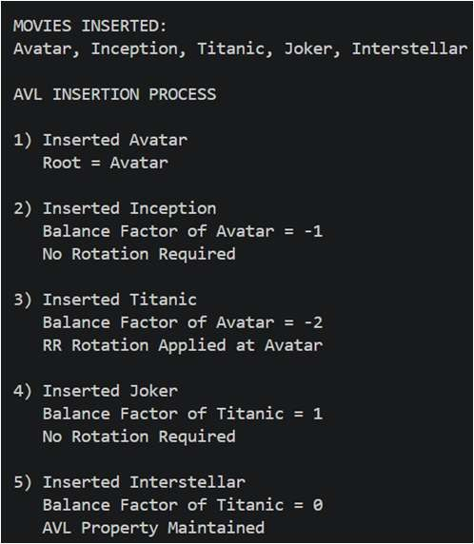
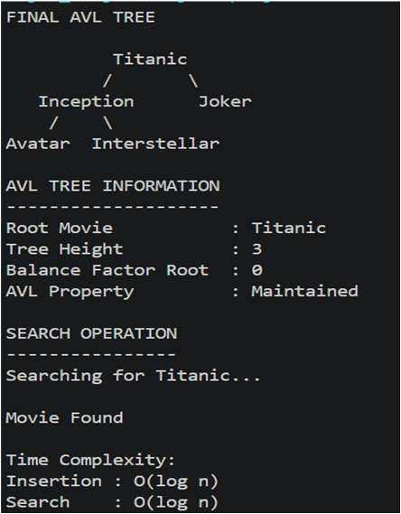
Results and Screenshots:
Time Complexity: AVL Insert, Search, and Delete operations are performed in O(log n) time due to automatic tree balancing.
Compared to a normal BST, the AVL Tree provides better worst-case performance because the tree remains balanced after every insertion and deletion.

GitHub Link: https

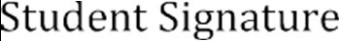 | 